Practice B
Piecewise Functions
Evaluate each piecewise function for x = −8 and x = 5.
1. 2.

3. 4.

Graph each function.
5. 6.
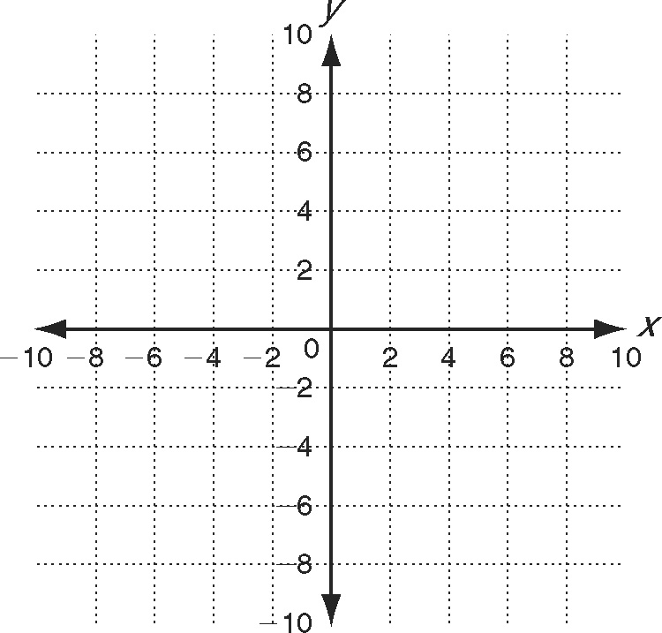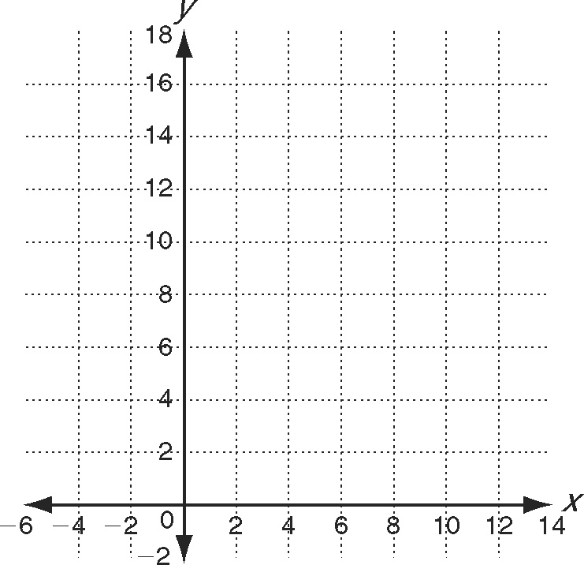
Solve.
7. An airport parking garage costs $20 per day for the first week. After that,
the cost decreases to $17 per day.
a. Write a piecewise function for the cost of
parking a car for x days.
b. What is the cost to park for 10 days?
c. Ms. Anderson went on two trips. On the first, she
parked at the garage for 5 days; on the second,
she parked at the garage for 8 days. What was
the difference in the cost of parking between the
two trips?

Practice B
1. −16, 0 2. 10, −3
3. −12, 25 4.
5. 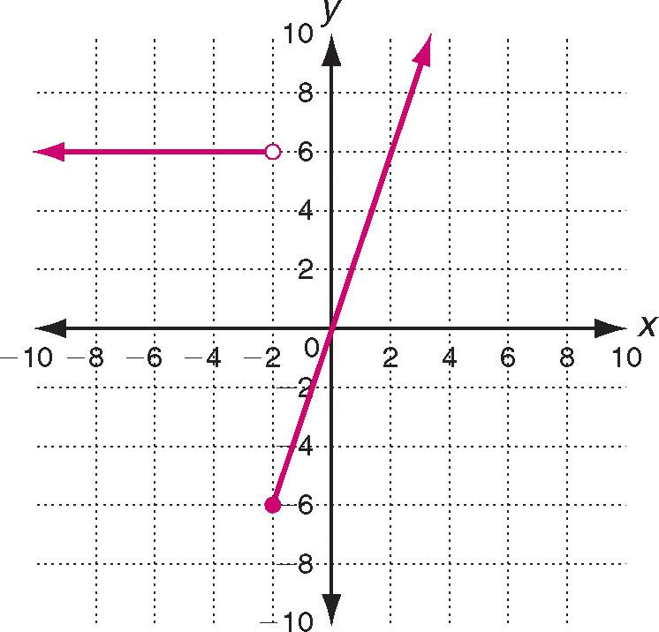
6. 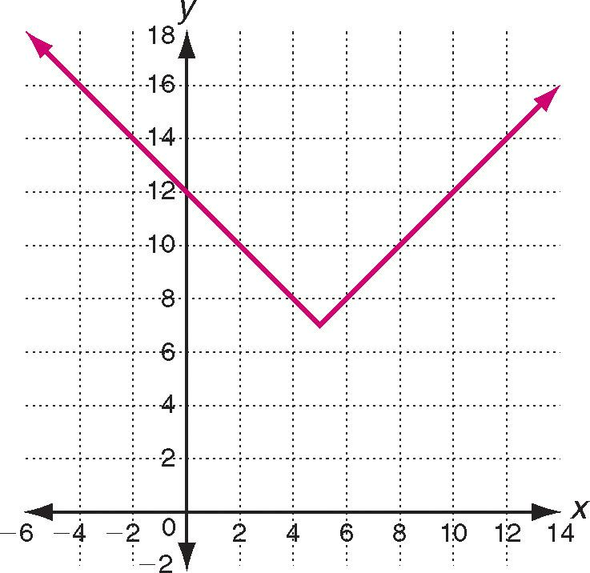
7. a.
b. $191
c. $57

Practice C
1. 8, 8, 17 2. −1.84, −2, 24
3. 11, 2, 210 4. −5.6, 0, −14
5. 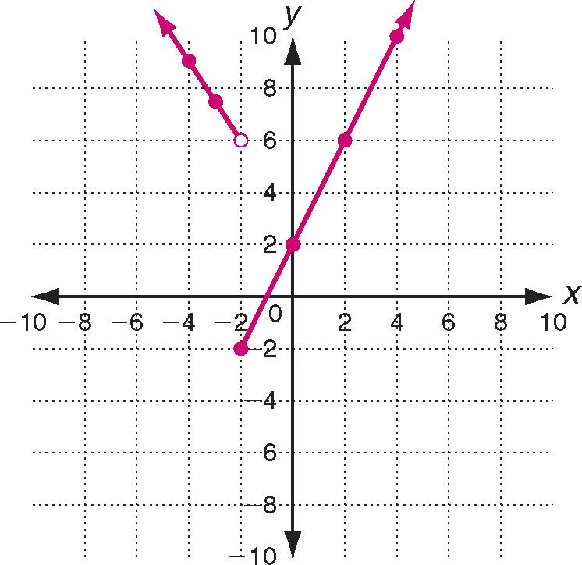
6. 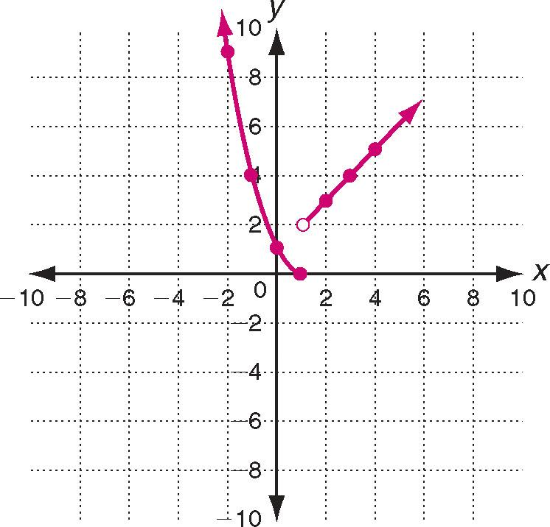
7. a.
b. $57

Reteach
1. 2; 6 2. −2; 7; 4; 14
3. p(−2) = 1; p(4) = 11 4. (1, −2); (1, −3)

x | g(x) = 2x | g(x) = x − 4
−2 | −2(−2) = 4
−1 | −2(−1) = 2
0 | −2(0) = 0
1 | −2(1) = −2 | 1 − 4 = −3
2 |  | 2 − 4 = −2
3 |  | 3 − 4 = −1
4 |  | 44 = 0

